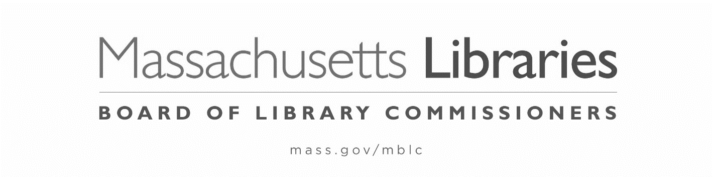

FY2024 STATE AID TO PUBLIC LIBRARIES
NOTIFICATION of REQUEST for FLEXIBILITY for the MATERIALS EXPENDITURE REQUIREMENT per 605 CMR 4.01

Request for flexibility: Each library shall be open at least the minimum required hours for its population group (refer to the minimum standards contained in 605 C.M.R.4.01(3)). A library that is open the required hours for a larger population group may, by request of the Library Director and Chair of the Board of Trustees, expend the required materials expenditure for that population group. The request shall be made by filing a “Notification of Request for Flexibility for the Materials Expenditure Requirement” with the Board of Library Commissioners as part of the State Aid to Public Libraries application. 605 CMR 4.01(5)

In accordance with 605 CMR 4.01(5), the municipality of _____________________________
is requesting flexibility for the Materials Expenditure Requirement.

__________________________________________________________________________________
Signature of Library Director Date

__________________________________________________________________________________
Signature of Trustee Chair Date

Actual FY2023 Hours and Days Open Per Week during the Compliance Period
(as reported on the FY2024 State Aid to Public Libraries Compliance Form)

Hours Open Per Week
Days Open Per Week
Evenings (after 5:00 p.m.) open per week

Actual Materials Expenditure Percentage During FY2023  (as reported on the FY2024 State Aid to Public Libraries Compliance Form) | %

Please attach this form to the Compliance Form and return to the
MBLC (attn: Uechi Ng at uechi.ng@mass.gov)
no later than October 6, 2023

FY2024 State Aid to Public Libraries
Minimum Standards for Hours of Service and Materials Expenditures
by Population

Libraries in communities with population | Recommended Minimum Hours Open per Week (At Least 38 Weeks in the Year)
(a) under 2,000 | 10 including some evening hours
(b) 2,000-4,999 | 15 including some evening hours
(c) 5,000-9,999 | 25 including some evening hours
(d) 10,000-14,999 | 40 some part five days, including some evening hours
(e) 15,000-24,999 | 50 some part five days, including some evening hours
(f) 25,000-49,999 | 59 open six days, including some morning, afternoon, and evening hours
(g) 50,000 and over | 63 open six days, including some morning, afternoon, and evening hours

Libraries in communities with population | Minimum Percentage of the Municipal Appropriation to the Library for Operations Which Must Be Spent on Library Materials
(a) under 2,000 | 20%
(b) 2,000-4,999 | 19.5%
(c) 5,000-9,999 | 19%
(d) 10,000-14,999 | 16%
(e) 15,000-24,999 | 15%
(f) 25,000-49,999 | 13%
(g) 50,000 and over | 12%

