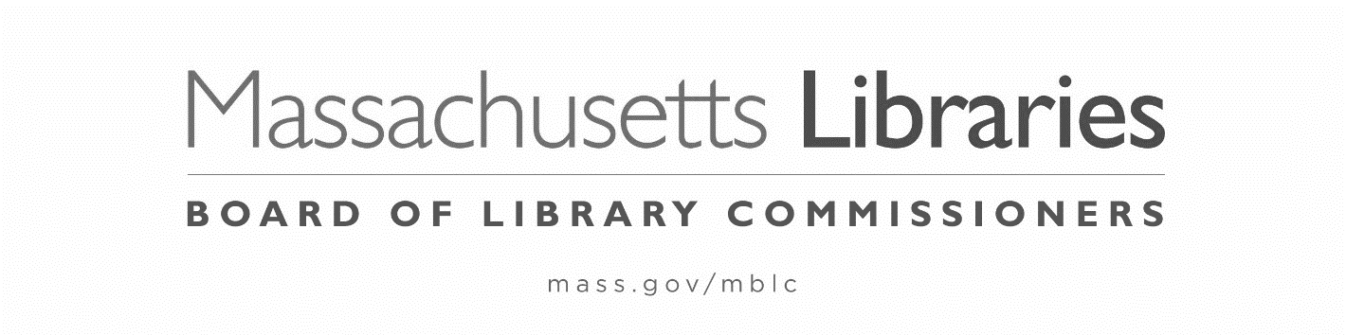

PETITION FOR WAIVER OF THE
FY2022 MUNICIPAL APPROPRIATION REQUIREMENT

The municipality of Choose an item. hereby petitions the Massachusetts Board of Library Commissioners for a waiver of the Municipal Appropriation Requirement (MAR) for Fiscal Year 2022.

Signature, Library Director: ____________________________________ Date:__________

Signature, Library Trustee Chair:________________________________ Date:__________

PLEASE NOTE: This is the first year of the 5 year waiver plan.
This petition is due postmarked by October 1, 2021 and the following four (4) items must be postmarked by November 5, 2021:

- Signed, completed FY2021/FY2022 Total Municipal Operating Budget/Disproportionate Cut Worksheet
  - usually filled out by the municipality’s financial officer (i.e. town accountant)

- Supporting municipal budget document(s), summarizing the final FY2021 and proposed FY2022 total operating and departmental budgets for the municipality

- One letter from a municipal official:
  - citing the fiscal hardship surrounding the municipality’s inability to meet the FY2022 MAR
  - explaining the municipality's FY2022 budget process regarding the library
  - providing evidence that any reduction to the library budget is not disproportionate relative to changes in other municipal departments and the overall municipal budget

- One letter from the library director and trustee chair:
  - explaining the library's FY2022 budget process and reasons why the municipality did not comply with the FY2022 MAR

Please answer the following questions:

1.Has the municipality held an election to raise revenues beyond the limitations of Proposition 2½ for FY2022?
YES ☐ NO ☐ DATE OF ELECTION Click here to enter a date.
If YES, what was the result of the election? PASSED ☐ FAILED ☐

2.Is further budgetary action expected that might increase the municipality's FY2022 appropriation to the library?
YES ☐ NO ☐

If YES, what form of action is expected? a) Override referendum ☐ b) Capital exclusion ☐
c) Debt exclusion ☐ d) Budget revision ☐ e) Other (please specify)

Proposed Date(s) of above action(s) Click here to enter a date.

THIS PETITION MUST BE sent electronically to uechi.ng@mass.gov BY OCTOBER 1, 2021
THE ADDITIONAL 4 ITEMS MUST BE POSTMARKED BY NOVEMBER 5, 2021.

